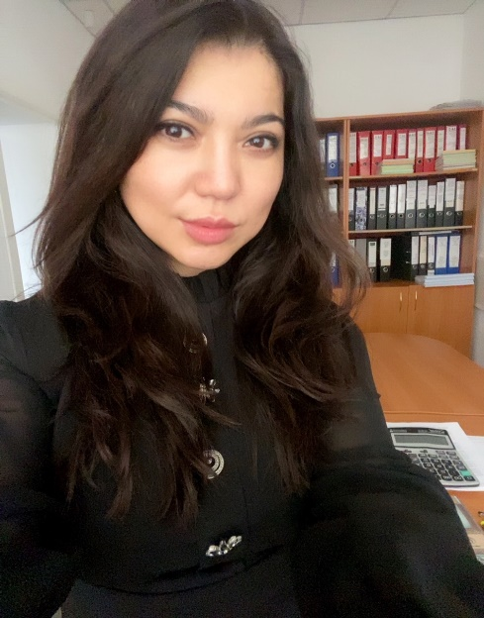

**Gazikhanova Zhanar Gazizovna**

Doctor of Philosophy PhD

Head of the Department of "Foreign Languages and Intercultural Communication"

**Contact information:**

Address: office 203, 17 Abaya str., Karaganda, 100012 Kazakhstan

Phone: 42-04-25 (ext.303)

E-mail: [shaikhyzada@yandex.ru](mailto:shaikhyzada@yandex.ru)

Working hours: Mon.-Fri. 09:00-17:00, lunch 13.00-14:00

**Education:**

**2014-2017** - E.A. Buketov Karaganda State University, Faculty of Foreign Languages, doctoral degree in the specialty "Foreign language: two foreign languages", PhD

**2008-2009** - Algarve University, Portugal (EU Erasmus Mundus educational Grant), Master's degree in "Education, Teacher Training and Humanities"

**2007-2009** - E.A. Buketov Karaganda State University, Faculty of Foreign Languages, Master's degree in "Foreign Language: Two Foreign Languages", Master of Education (Foreign Languages)

**1999-2004** - E.A. Buketov Karaganda State University, Faculty of Foreign Languages, specialty: foreign Philology, teacher of English and German languages and literature

**Work experience:**

**2020 - present** - Head of the Department of Foreign Languages and Intercultural Communication of the CHU "Bolashaq Academy"

**2018-2020** - Head of the Department of Foreign Philology of the E.A. Buketov KarSU

**2017-2018** - Head of the Department of Foreign Languages of the E.A. Buketov KarSU

**2014-2017** – Head of the Center for the Development of Multilingual Education of the E.A. Buketov KarSU

**2013-2014** - Head of the Department of Foreign Languages of the E.A. Buketov KarSU

**2010-2013** - Head of the Department of Foreign Languages of Natural Faculties of the E.A. Buketov KarSU

**2009-2010** - Senior teacher of the Department of Foreign Languages of Natural Faculties of the E.A. Buketov KarSU

**2004-2007** - Teacher of the Department of Foreign Languages of Natural Faculties of the E.A. Buketov KarSU

**Teaching experience: 18 years**

**Research interests:** Research interests related to the fields of foreign language education and foreign philology, multilingual education, professionally oriented teaching of foreign languages, as well as to the field of management and organization of the educational process.

**Scientific and educational-methodical works**

More than 70 scientific publications have been published, including 3 articles included in the Scopus database, more than 20 publications in journals recommended by COXON MES RK.

1 monograph, about 20 educational and methodical manuals, 3 electronic educational publications have been published. One of the authors of Standard Curricula: Basic English course for multilingual education specialties approved by the Ministry of Education and Science of the Republic of Kazakhstan; professionally oriented foreign language for a number of non-linguistic specialties of universities approved by the Ministry of Education and Science of the Republic of Kazakhstan; advanced training programs in English for university teachers.

**Implementation of grant research projects and funded research topics:**

**2015-2017** - Scientific and methodological support of the continuity of multilingual education in the "school - university" system, MES RK

**2015-2017** – Scientific and methodological support of continuous language training of engineering personnel in the conditions of multilingual education (college-university), MES RK

**Awards and incentives**

**2022** - Letter of thanks from the Akim of Karaganda for participation in the socio-political life of the city and conscientious work

**2018** - Certificate of Honor of the Minister of Education and Science of the Republic of Kazakhstan for contribution to the field of education

**2017** - Honorary diploma of the Rector of the E.A. Buketov KarSU for conscientious work and contribution to the development of the university

**2017** - Diploma of the laureate of the All-Russian competition for the best scientific book

**2017** - Letter of thanks from the director of the branch of JSC "NCPC "Orleu" Pavlodar

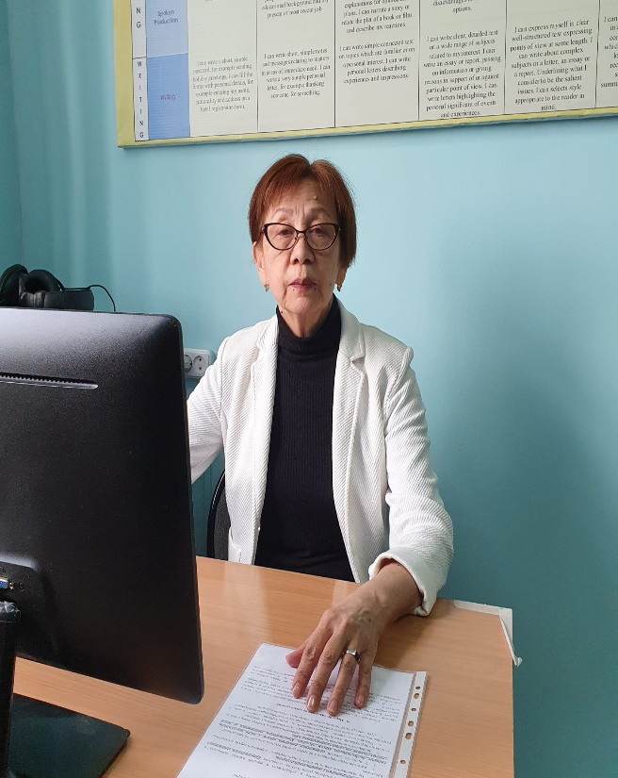

**Begakhmetova Balzhan Kairgeldyevna**

Associate Professor of the Department of Foreign Languages and Intercultural Communication

**Contact information:**

**Address:** office 203, 17 Abaya str., Karaganda, 100012 Kazakhstan

**Phone**: 42-04-25 (ext.303)

**E-mail:** [zhannaastra15@mail.ru](mailto:zhannaastra15@mail.ru)

**Working hours**: Mon.-Fri. 09:30-15:00

**Education:**

**2012-2014** - Central Kazakhstan Academy, Master's degree in Philology, academic degree of Master of Humanities.

**1975-1981** - Higher education: Kazakh State University named afterKirov (Almaty), specialty "History in a foreign language".

**Work experience:**

**2003-present** – Bolashaq Academy, Department of Foreign Languages and Intercultural Communication

**1993-2003** – Department of Foreign Languages of Karaganda State Medical University

**1981-1993** – teacher of history and foreign language in a general education institution

**Teaching experience: 42 years**

**Scientific interests:** they are related to the methodology of foreign language education.

**Scientific and educational-methodical works**

About 30 scientific articles on the methodology of foreign language education and cognitive linguistics have been published. Co-author of the Phraseological Frequency Dictionary (in 5 languages), monographs "Questions of linguistics of the 21st century" and "Dialogue of cultures in the modern world". Participated in a number of international scientific and practical conferences.

**Awards:**

**2017** - Certificate of Honor of the Ministry of Education and Science of the Republic of Kazakhstan

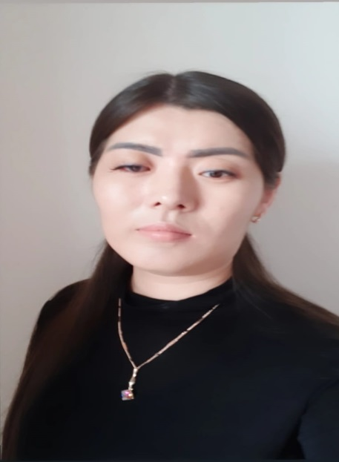

**Abdresheva Madina Kabbasovna**

Master of Pedagogical Sciences

Senior Teacher of the Department of Foreign Languages and Intercultural Communication

**Contact information:**

Address: office 203, 17 Abaya str., Karaganda, 100012 Kazakhstan

Phone: 42-04-25 (ext.303)

E-mail: [mada_15@mail.ru](mailto:mada_15@mail.ru)

Working hours: Mon.-Fri. 09:00-15:00

**Education:**

**2016-2018** – Karaganda State University named after Academician E.A. Buketov, Faculty of Foreign Languages, specialty - foreign language "two foreign languages", qualification – Master of Pedagogical Sciences.

**2013-2016** – Karaganda State University named after Academician E.A. Buketov, Faculty of Foreign Languages, specialty – foreign language: "two foreign languages (English)", qualification – Bachelor of Education

**2010-2013** – Karaganda College of Current Education, "Translation Business" (with honors)

**Work experience:**

**2021 - present** – Senior Teacher of the Department of Foreign Languages and Intercultural Communication at the Bolashak Academy.

**2019 (February) - 2022 (June)** - English teacher, British Council Astana

**2018 (September) - 2021 (August)** - Teacher of the Department of Foreign Languages, E.A. Buketov KarSU

**Teaching experience:** 5 years

**Scientific interests:** inclusive education, multilingual education, online platforms

**Scientific and educational-methodical works**

The number of published scientific and educational works is more than 10.

Of these:

- in publications recommended by COXON MES RK, – 2

- in publications published in the RSCI database – 3.

**Scientific internships:**

**2017 (June)** Internship on the course "Intensive language course" at the Language school Jipka (Prague, Czech Republic);

**2019 (July)** Internship in the course "Teaching English to students with different levels and backgrounds" at Cyprus International University

**Information about advanced training:**

**2018 (April 16)** Certificate confirming participation in the distance learning course "Methodological support of the inclusive education process" at the E. A. Buketov KarSU

**2019 (June 23)** Certificate Teaching English as foreign language – TEFL, grade A

**2019 (December 9-13)** Certificate of "Kazakhstan Education Research Association" at Nazarbayev University

**2020 (March 2-5)** Certificate "Massive Oriented Online Courses" in the British Council

**2020 (April 23)** Certificate "Teaching English in higher education" at Macmillan Education in Kazakhstan. Online webinar. Preparation of the team "Kyran", out of 5 students who took 1st place in the I Republican Pedagogical Olympiad "Creative teacher of the XXI century", Taraz, April 25-26, 2017.



**Abilzhan Altynai Bolatkyzy**

Master of Pedagogical Sciences, Senior Teacher of the Department of Foreign Languages and Intercultural Communication

**Contact information:**

Address: office 203, 17 Abaya str., Karaganda, 100012 Kazakhstan

Phone: 42-04-25 (ext.303)

E-mail: [Altinay_96_96@inbox.ru](mailto:Altinay_96_96@inbox.ru)

Working hours: Mon.-Fri. 09:00-17:00, lunch 13.00-14:00.

**Education:**

**2019-2021** - Master's degree – E.A. Buketov Karaganda State University (now E.A. Buketov Karaganda University) Faculty of foreign languages, Specialty 5B011900 Foreign language: two foreign languages (English).

**2014-2018** - Full-time higher education – Bolashaq Academy, Faculty of foreign languages, Specialty 5B011900 Foreign language: two foreign languages (English).

**Work experience:**

**2021 - present** - Senior Teacher of the Department of "Foreign Languages and Intercultural Communication" CHU Academy "Bolashaq"

**2018 – 2021** - Multidisciplinary Humanitarian and Technical College

**Teaching experience: 5 years**

**Scientific interests:** They are connected with the spheres of teaching foreign languages and intercultural communication of teaching foreign languages, as well as with the sphere of the organization of the educational process.

**Scientific and educational-methodical works**

Published more than 15 scientific articles, 3 projects

**Professional development:**

- “Professional competence of a teacher of general education disciplines in the conditions of modernization of the system of technical and vocational education” - National Center for Advanced Training “Orleu” 40 hours, 21.01-25.01.2019, Karaganda

- “Modern approaches in technical and vocational education" - Educational and Methodological Center for the Development of Education of the Karaganda region 18 hours, 06/19/2019 Karaganda

- “Linguistics and intercultural communication (French)”- Institute of Retraining and advanced Training “Bilim" 72 hours, 02.09-20.09.2022 Karaganda

- “Modern approaches in teaching English and intercultural communication" - Bilim Institute of Retraining and Advanced Training 72 hours, 28.09-12.10.2022, Karaganda

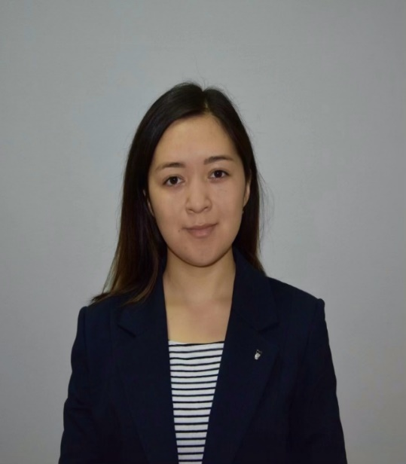

**Dauletbaeva Aida Erlanovna**

Master of Pedagogical Sciences,

Teacher of the Department of "Foreign Languages and Intercultural Communication"

**Contact information:**

Address: office 203, 17 Abaya str., Karaganda, 100012 Kazakhstan

Phone: 42-04-25 (ext.303)

E-mail: [aida-maerbekova@inbox.ru](mailto:aida-maerbekova@inbox.ru)

Working hours: Mon.-Fri. 09:00-17:00, lunch 13.00-14:00.

**Education:**

**2019-2021** - Master's degree in Karaganda State University named after E.A. Buketov (Karaganda), Faculty of Foreign Languages, 5B011900 Foreign language: two foreign languages (English). Specialty "Foreign language: two foreign languages (English)".

**2015-2019** - Full-time higher education Karaganda State University named after E.A. Buketov (Karaganda), Faculty of Foreign Languages, 5B011900 Foreign language: two foreign languages (English). Specialty "Foreign language: two foreign languages (English)".

**Work experience:**

**2021 – present** - Teacher of the Department of "Foreign Languages and Intercultural Communication" CHU Academy "Bolashaq"

**Teaching experience: 2 years**

**Scientific interests:** They are connected with the study of the pedagogical aspect in the system of foreign language education, with the development of scientific potential provided that an individual trajectory of professional development is built, technological innovations and innovations in linguodidactics, pedagogical management.

**Scientific and educational-methodical works**

Published more than 20 scientific articles, 2 projects

**Awards:**

**2022** - Honorary diploma of the Rector of the CHU Academy "Bolashaq" for his contribution to the training of future specialists and active participation in the public life of the Academy

**Professional development:**

- "Modern approaches in teaching English and intercultural communication" in the amount of 72 hours, 10-28.08.22 (Karaganda),

- "Deep Reading" in the amount of 36 hours, 21.07-5.08.22 (Galway, Ireland),

- "Principles of Academic Writing" in the amount of 36 hours, 21.07-5.08.22 (Galway, Ireland),

- "English for IELTS" in the amount of 72 hours, 5-24.09.22 (Karaganda).

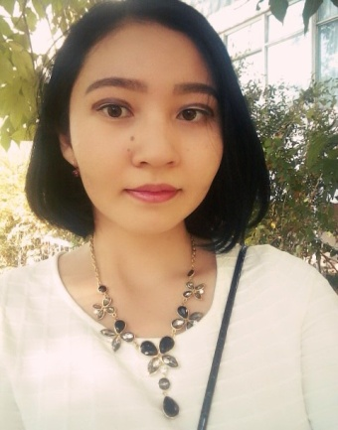

**Mombekova Meruert Maratkyzy**

Master of Pedagogical Sciences,

Teacher of the Department of "Foreign Languages and Intercultural Communication"

**Contact information:**

Address: office 203, 17 Abaya str., Karaganda, 100012 Kazakhstan

Phone: 42-04-25 (ext.303)

E-mail: mika_9807@mail.ru

Working hours: Mon.-Fri. 09:00-17:00, lunch 13.00-14:00.

**Education:**

**2022-2025** - Academician E.A. Buketov Karaganda University

Doctoral education program: "Foreign language: two foreign languages"

**2020-2022** - Academician E.A. Buketov Karaganda University

Master educational program: "Foreign language: two foreign languages"

**2017-2020** - Academician E.A. Buketov Karaganda State University

Bachelor Educational program: Foreign Philology

**2013-2017** - Karaganda Humanitarian College

Specialty: primary school foreign language teacher

**Work experience:**

**2021-2023** - Academician E.A. Buketov Karaganda University

Position: Senior teacher of the Department of Theory and Methodology of Foreign Language Training

**2020-2021** – Private Institution “College of Foreign Languages” (Lingva)

Position: English teacher

**Teaching experience:** 3 years

**Research interests:** research interests relate to the areas of pedagogical and foreign language education, teaching methods, multilingual education, professionally-oriented teaching of foreign languages, as well as to the field of management and organization of the educational proces**s.**

**Scientific and educational-methodical works:** about 20 scientific publications have been published, including 3 publications in journals recommended by the Committee on Education and Science of the Ministry of Education and Science of the Republic of Kazakhstan and 1 article included in the Scopus database.

**Awards and incentives:** laureate of the Presidential Scholarship (2020), winner of prizes of the 1st, 2nd and 3rd degrees at international scientific conferences.



**Ainur Y. Alzhanova**

Master of Arts

Senior Lecturer of the Department of “Foreign Languages and Intercultural Communication”

**Contact information:**

Address: 100017 Kazakhstan, Karaganda, N. Abay str., 17, office 203.

Phone: 42-04-25 (ext. 303)

E-mail: ainuralzhanova@bk.ru

Work schedule: Mon-Fri 09:00-17:00, lunch 13:00-14:00.

**Education:**

2021-2024. - Karaganda University named after academician E.A. Buketov, Faculty of Philology, PhD student

2017-2019. - Central-Kazakhstan Academy, Faculty of Language and Translation, Master's degree in “Philology”, Master of Arts.

2010-2012. - Kazakhstan Academy of Engineering and Technology, Astana, “Economics”, Bachelor of economics and business

2006-2009. - Karaganda State University named after E.A. Buketov. Faculty of Foreign Languages, specialty “Foreign Language: two foreign languages (English), Bachelor of English and German languages

2002-2006. - Zhezkazgan Humanitarian College, specialty “Foreign language”, Teacher of English in a basic school.

**Work experience:**

2024 - up to the present day - a senior teacher of the “Department of Foreign Languages and Intercultural Communication” Private Educational Institution “Bolashaq Academy”

2021-2024 – PhD candidate of Karaganda University named after academician E. A. Buketov, 8D02301 - Philology

2019-2017 - Lecturer of the Department of “Theory and Practice of English Language” of the Central Kazakhstan Academy, Deputy Dean for Scientific Research of the “Theory and Practice of English Language” Department

2011-2019 - Lecturer of “College of Foreign Languages”, Karaganda

2009-2011 - Lecturer at the College of Business and Transportation, Zhezkazgan

2006-2007 - Teacher of English at School No. 9, Zhezkazgan

**Teaching experience:** 16 years

Scientific interests: Scientific interests refer to the spheres of cognitive research in the field of linguistics, theory and practice of translation, professionally-oriented teaching of foreign languages, as well as teaching methods.

**Scientific and methodological works**

Published more than 20 scientific articles, including 1 article included in the Scopus database and 3 publications in journals recommended by CQASE of the Ministry of Education of the Republic of Kazakhstan

**Awards and encouragements**

2021 - Diploma of the I degree was awarded for participation and victory in the republican competition “The Best Master of Kazakhstan”, held in order to widely promote the program article of the President Nursultan Nazarbayev “To the future: spiritual revival” among teachers of educational organizations, universities and colleges.