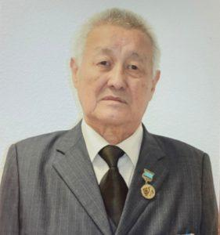

**Nabi Yelikbayev**-Doctor of Philosophy, Professor, Academician of the Academy of Social Sciences of the Republic of Kazakhstan.

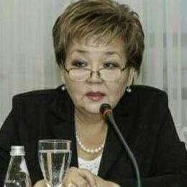

**Bekturganova Bakhytzhamal Erkenovna**-Doctor of Philosophy, Professor

Native of Almaty, Kazakh, ex-chairman of the Movement "Women of Kazakhstan", Chairman of the Board of the Association of Sociologists and Political Scientists of Kazakhstan (ASiP), ex-co-president of the Eurasian Sociological Association (Moscow, Russia), ex-candidate for deputy of the Mazhilis of the Parliament in October 1999. Doctor of Philosophy, Academician of the Academy of Sociology of the Republic of Kazakhstan. 1972-1977-Kazakh State University named after S. M. Kirov, Faculty of Philosophy and Economics, Department of Philosophy, Almaty. 1978-1985-Lecturer of the Department of Philosophy of the Almaty Institute of National Economy. 1985-1988-Postgraduate study and PhD thesis defense in specialty 09.00.01. (Social Philosophy) at the Lomonosov Moscow State University. 1989-1991-Senior lecturer of the Department of Philosophy of the Almaty Institute of National Economy. 1991-1992-Student of the Department of Philosophy at the Institute of Advanced Training of Teachers of Social Sciences and Humanities at the Lomonosov  
Moscow State University 1991-1993-Associate Professor of the Department of Philosophy of the Kazakh State Academy of Management. 1992-Defended his doctoral dissertation at the Lomonosov Moscow State University 1993-May 1995-Director of the Center for Economic Sociology under the Kazakh.ГАУ. State University 1995-1996-Director of the Institute of Sociology and Political Science of the National Academy of Sciences of the Republic of Kazakhstan. 1995 - present-Chairman of the Board of the Association of Sociologists and Political Scientists of Kazakhstan. 1997-1998-Non-staff Professor of the Department of Philosophy of the Kazakh Agrarian University, Chairman of the Commission for admission of entrance exams to postgraduate studies and candidate minimums, 2007-2015-Founder and General Director of the Institute of Political Decisions. 2019-present-Professor of the Department of General Education Disciplines of CHU "BOLASHAQ Academy", subjects taught-philosophy, sociology

Member of the working commissions of the Presidential Council on Women, Family and Demography of the Republic of Kazakhstan and the Presidential Council under the President of the Republic of Kazakhstan. Author (head-academician K. A. Sagadiev) of the government concept "Formation of a new socio-economic behavior of citizens of the Republic of Kazakhstan", where the idea of stimulating the formation of the middle class of Kazakhstan by means of state policy was first voiced (published in" Kazakhstanskaya Pravda " in January 1995) Head and developer of more than 1000 research projects of international, regional, republican levels and author of reports based on project results. Author of scientific monographs ("The Middle class – a "test" for modernity. History. Theory. Statistics", "Sociology of Women: Kazakhstan 1994-1998", " Uyghur Extremism in Central Asia: Myth or Reality?" etc.), numerous scientific and journalistic articles, essays, pamphlets. Provides expert advice to state and local government bodies, mass media, international and local analytical services, foreign diplomatic missions and embassies, political parties and public associations.

Languages: Kazakh-native, Russian-fluent, English-spoken, within the limits of communication.

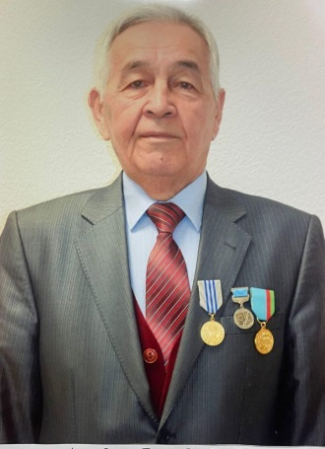

**Adambekov Yermekbay Kopbaevich** -Candidate of Historical Sciences, Professor

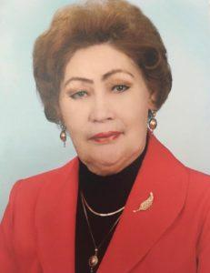

**Sattarova Farida Fattakhovna** - Candidate of Philosophy, Associate Professor of the Higher Attestation Commission, Moscow:(1983);Associate ProfessorКарГУ, E. A. KarSU. Buketova2008)Associate Professor of the Department of OOD AkademiBolashaq

Member of the "Philosophical Society of Kyrgyzstan". Chairman: Doctor of Philosophy, Professor Шарипова Эркайым Erkaiym Sharipova.. Bishkek.Toirgieia;.  
member of the Philosophical Society of the Institute of Philosophy, Political Science and Religious Studies of the Ministry of Education and Science of the Republic of Kazakhstan NC Almaty

He has morethan 250 scientific publications: monographs, textbooks and manuals,scientific articles, electronic textbooks. Research interests: problems of philosophy and methodology of science, Kazakh philosophy and culture

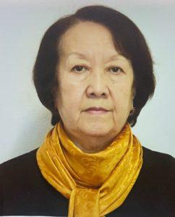

**Dikanbayeva Saira Alkeevna**-Candidate of Philological Sciences, Associate Professor of the Higher Attestation Commission, Professor of the Bolashaq Academy Bolashaq. The number of published scientificо- and methodological works is more than 80, including two collective monographs, more than 10 teaching aids. For three years he has been participating in the international seminar of the Russian Language Department of the RUDN University Medical Institute (Russian Federation)” and the Center for Humane Pedagogy of the BOLASHAQ Academy BOLASHAQ (RK) “Topical issues of multicultural education in the Russian Federation, annually makes presentations at seminars.

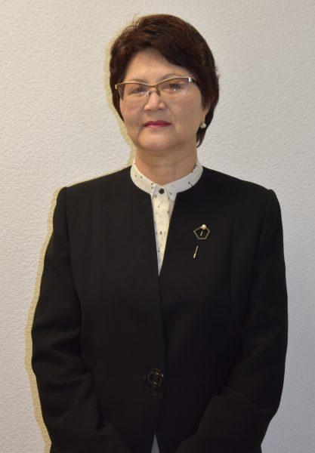

**Shashchanova Maira Balievna**-Candidate of Technical Sciences, Professor of the Bolashaq AcademyBolashaq.

Education. Full-time higher education (1972-1977), USSR, Kazakh SSR, Karaganda Order of the Red Banner of Labor Polytechnic Institute.

Full-time postgraduate study (1984-1987) Integrated Research and Design Institute of Solid Fuel Mineral Processing IOTT Moscow Lyubertsy of the Moscow region.

Academic degree-Candidate of Technical Sciences (decision of the Higher Attestation Commission of Russia of October 08, 1993, Protocol No. 1). Candidate of Technical Sciences (by the decision of the Higher Attestation Commission of the Republic of Kazakhstan dated June 22, 2001)

Academic title-Associate Professor of the Ministry of Education and Science of the Republic of Kazakhstan, specialty 051300 "Informatics, Computer Engineering and Management" (Protocol No. 9 of 09.09.05).

Academic titles: Corresponding member of the International Academy of Informatization of the Republic of Kazakhstan (MAIN). C 2011г

Research interests: data analysis and processing in various fields, information systems and technologies in education, in economic systems, neural network technologies and their application, information and communication technologies.

Scientific and methodological works. Author of more than 100 scientific and methodological works in international and national publications, collections of scientific works, including 3 inventions, 1 textbook, 18 teaching aids, 1 monograph, 3 certificates of state registration of rights to the object of copyright, more than 10 methodological recommendations for conducting various disciplines and workshops programs. H-index=2.

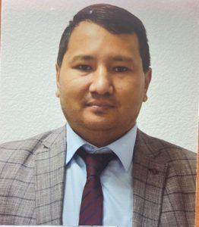

**Kasenov Elaman Baltaevich**-Candidate of Historical Sciences, Associate Professor

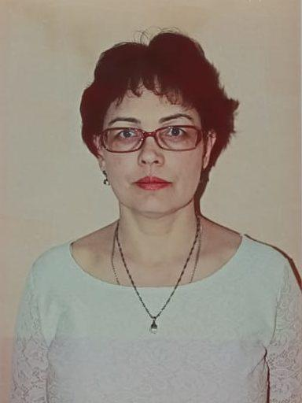

**Irina Grigorchuk**-senior lecturer of the Department of OOD, teacher of English, Latin and Russian languages. She graduated from the Faculty of Philology КарГУof the E. A. Buketov KarSU and the Lingua Institute of Language and Translation.ЛингваShe worked as a teacher of Russian language and literature at School 97, as a teacher of Russian and Latin languages at Karaganda State Medical University, and at the Themis Law Institute. Since 2007, he has been working atthe Bolashak Karaganda Academy. He has more than forty scientific publications, and his research interests include methods of teaching foreign languages, and the humanitarian heritage of ancient languages.or Academician of the Academy of Social Sciences of the Republic of Kazakhstan.

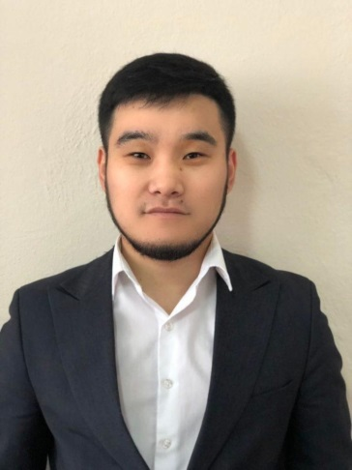

**Aitzhan Daulet Kenzhebayuly**– Master of Humanities, Senior Lecturer

**Education**

**Full-time higher education** (2014-2017) Karaganda State University named after E. A. Buketov. Specialty Foreign language: 2 foreign languages

**Master**'s degree (2017-2019) in Science and Education. Specialty "Foreign Philology" Central Kazakhstan Academy Faculty of " Language and Translation”

**Labor biography.** Lecturer at the College of Foreign Languages (2017-2021). Teacher of the Department of Theory and Practice of the English Language. Deputy Dean for Educational and Career Guidance of the Faculty

**Research interests:** methods of teaching a foreign language.

**Scientific and methodological works.** Author of 10 scientific and methodological works in collections of scientific papers

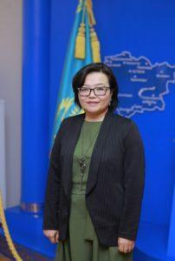

**Kosmanova Assel Beysengazykyzy-**Master of Humanities, Senior Lecturer

**Education:**

**Full-time higher education**(1998-2002) Karaganda Institute of Contemporary Education "Bolashak", specialty "Political Science", Qualification: Political scientist. Teacher of political science;

**Master**'s degree program (2017-2019) Karaganda State University named after V. I. Abramovich. Academician E. A. Buketov, specialty "Cultural Studies", Master of Humanities;

**Teaching activities.**

He has been working at the Bolashaq Academysince2004. In 2020, she became the winner in the category "Best teaching in a remote format".

**Scientific and methodological works.**

Published more than 10 scientific and methodological papers in international and national publications, collections of scientific papers.

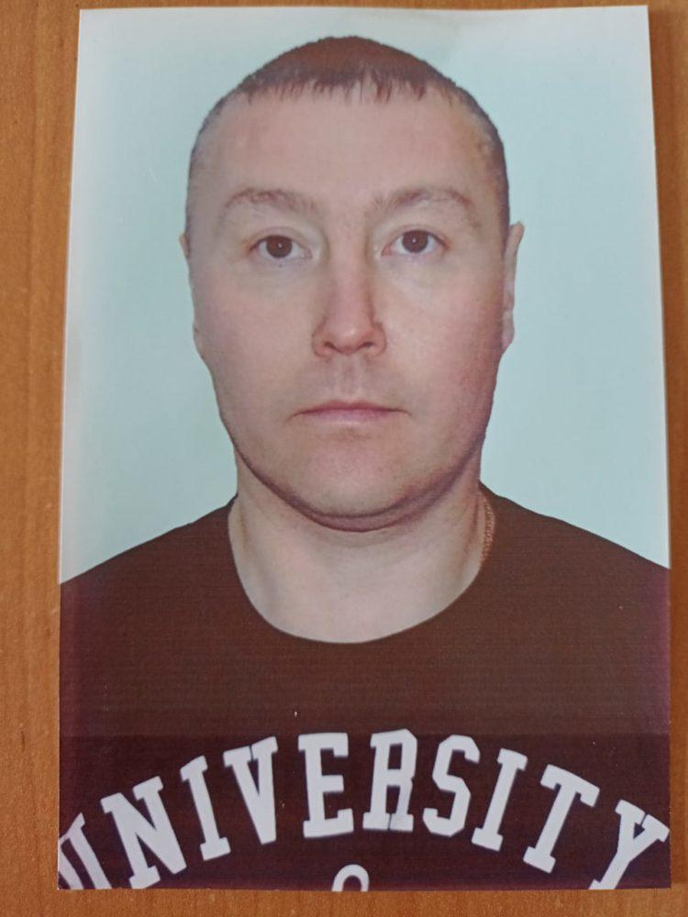

**Mukushev Daniyar**– Senior lecturer;