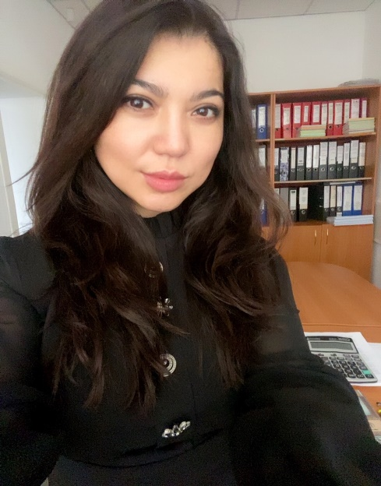

Gazikhanova Zhanar Gazizovna

Doctor of Philosophy PhD
Head of the Department of "Foreign Languages and Intercultural Communication"

Contact information:
Address: office 203, 17 Abaya str., Karaganda, 100012 Kazakhstan
Phone: 42-04-25 (ext.303)
E-mail: shaikhyzada@yandex.ru
Working hours: Mon.-Fri. 09:00-17:00, lunch 13.00-14:00

Education:
2014-2017 - E.A. Buketov Karaganda State University, Faculty of Foreign Languages, doctoral degree in the specialty "Foreign language: two foreign languages", PhD
2008-2009 - Algarve University, Portugal (EU Erasmus Mundus educational Grant), Master's degree in "Education, Teacher Training and Humanities"
2007-2009 - E.A. Buketov Karaganda State University, Faculty of Foreign Languages, Master's degree in "Foreign Language: Two Foreign Languages", Master of Education (Foreign Languages)
1999-2004 - E.A. Buketov Karaganda State University, Faculty of Foreign Languages, specialty: foreign Philology, teacher of English and German languages and literature

Work experience:
2020 - present - Head of the Department of Foreign Languages and Intercultural Communication of the CHU "Bolashaq Academy"
2018-2020 - Head of the Department of Foreign Philology of the E.A. Buketov KarSU
2017-2018 - Head of the Department of Foreign Languages of the E.A. Buketov KarSU
2014-2017 – Head of the Center for the Development of Multilingual Education of the E.A. Buketov KarSU
2013-2014 - Head of the Department of Foreign Languages of the E.A. Buketov KarSU
2010-2013 - Head of the Department of Foreign Languages of Natural Faculties of the E.A. Buketov KarSU
2009-2010 - Senior teacher of the Department of Foreign Languages of Natural Faculties of the E.A. Buketov KarSU
2004-2007 - Teacher of the Department of Foreign Languages of Natural Faculties of the E.A. Buketov KarSU

Teaching experience: 18 years

Research interests: Research interests related to the fields of foreign language education and foreign philology, multilingual education, professionally oriented teaching of foreign languages, as well as to the field of management and organization of the educational process.

Scientific and educational-methodical works
More than 70 scientific publications have been published, including 3 articles included in the Scopus database, more than 20 publications in journals recommended by COXON MES RK.
1 monograph, about 20 educational and methodical manuals, 3 electronic educational publications have been published. One of the authors of Standard Curricula: Basic English course for multilingual education specialties approved by the Ministry of Education and Science of the Republic of Kazakhstan; professionally oriented foreign language for a number of non-linguistic specialties of universities approved by the Ministry of Education and Science of the Republic of Kazakhstan; advanced training programs in English for university teachers.

Implementation of grant research projects and funded research topics:
2015-2017 - Scientific and methodological support of the continuity of multilingual education in the "school - university" system, MES RK
2015-2017 – Scientific and methodological support of continuous language training of engineering personnel in the conditions of multilingual education (college-university), MES RK

Awards and incentives
2022 - Letter of thanks from the Akim of Karaganda for participation in the socio-political life of the city and conscientious work
2018 - Certificate of Honor of the Minister of Education and Science of the Republic of Kazakhstan for contribution to the field of education
2017 - Honorary diploma of the Rector of the E.A. Buketov KarSU for conscientious work and contribution to the development of the university
2017 - Diploma of the laureate of the All-Russian competition for the best scientific book
2017 - Letter of thanks from the director of the branch of JSC "NCPC "Orleu" Pavlodar

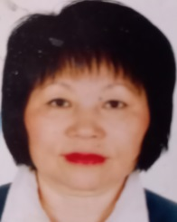

An Ekaterina Donginovna

Candidate of Philological Sciences, Associate Professor of the Higher Attestation Commission
Associate Professor of the Department of Foreign Languages and Intercultural Communication

Contact information:
Address: office 203, 17 Abaya str., Karaganda, 100012 Kazakhstan
Phone: 42-04-25 (ext.303)
E-mail: yekaterina.an@gmail.com
Working hours: Mon-Fri 09:00-17:00, lunch: 13:00 - 14:00

Education:
2009 (September) - Qualification "Teacher of the French language of the highest category"
1993 (July) - Academic title Associate Professor of the Higher Attestation Commission of the Republic of Kazakhstan (specialty: "Linguistics")
1991 (16.09-17.11) - Internship in the specialty "Methods of intensive foreign language teaching" at the Center for Intensive Foreign Language Teaching at Moscow State University. Lomonosov by the method of prof. G.A. Kitaygorodskaya for teachers of English and French.
1984 (March) - Academic degree of Candidate of Philology.sciences (specialty: 10.02.05-Romance languages)
1982-1984 - MOPI named after N.K.Krupskaya (Moscow Regional Pedagogical Institute). Postgraduate study
1970-1974 - APIA (Alma-Ata Pedagogical Institute of Foreign Languages), Faculty of French

Work experience:
2021-present - Associate Professor of the Department of "Foreign Languages and Intercultural Communication" of the Academy "Bolashaq"
2020-2021 - Associate Professor of the Department of "Foreign Languages" of Karaganda Technical University
2014-2020 - Associate Professor of the Department of "Foreign Languages" of the NAO "Medical University of Karaganda"
2011-2014 - Teacher of the "Center for Medical Education and Innovative Technologies of the Center for Human Resource Management" of the NAO "Medical University of Karaganda"
2007-2011 - teacher of English and French of the "Murager boarding School"
2003-2006 - Associate Professor of the Department of "Foreign Languages" of MSTU (Multidisciplinary Humanitarian and Technical University)
2002-2003 - Head of the Department of "Foreign Languages”, KazFarmi (Kazakhstan Pharmaceutical Institute)
2000-2002 - Associate Professor of the Department of "Foreign Languages" of KazFEU (Kazakhstan Financial and Economic University)
1999-2000 - Associate Professor, Head of the Department of "Second foreign Language" of the Lingua Institute
1983-1999 - senior teacher, Associate Professor, Head of the Department of "Foreign Languages" of Karaganda Medical University
1978-1982 – post-graduate student of the Department of "Lexicology of the French language" APII (Alma-Ata Pedagogical Institute of Foreign Languages)
1975-1980 - senior laboratory assistant of the Department of "Foreign Languages" Karaganda Medical University
1974-1975 - teacher of French at school No. 24 (Temirtau)

Teaching experience: more than 45 years

Research interests: Research interests are aimed at studying the problems of linguistics (word formation of modern French and English languages), as well as issues of methods of teaching foreign languages (intensification of the educational process in English).

Scientific and educational-methodical works
Author of several dozens of scientific-linguistic and scientific-methodical publications, including in journals recommended by the RSCI and CCSON
Participant of International, republican and regional scientific and practical conferences.

Scientific and pedagogical activity:
2007 - Master class for principals of schools in Karaganda and the Karaganda region on the methodology of intensive foreign language teaching
1989 - Participation in the All-Union Meeting of members of the Council of UMO on Foreign Languages on the basis of the Moscow Linguistic University
1976 - Participation in the work of WHO (World Health Organization) as a French translator

Awards:
Awarded with Diplomas, as well as Honorary Diplomas of the Ministry of Education and Science of the Republic of Kazakhstan, the Regional Department of Education, the Republican Scientific and Practical Center "Daryn".

Advanced training courses:
- TEFL Program Columbia International University;
- CEELT: The British Council and the Soros Foundation (for teachers of English on a competitive basis);
- Department for Culture and Cooperation of the Embassy of France in Kazakhstan and the Karaganda Regional Department of Education (for teachers and teachers of secondary and higher educational institutions);
- MAN RK (for teachers and specialists working with gifted children);
- "Netology-Group Online Learning Center": "Modern educational environment and new aspects in teaching foreign languages (on the example of the UMK FORWARD edited by M.V.Verbitskaya)". Moscow;
- Elsevier: "Improvement of professional competencies of scientific and educational personnel" (for scientific and pedagogical workers). Russia and the East. Europe.

Begakhmetova Balzhan Kairgeldyevna

Associate Professor of the Department of Foreign Languages and Intercultural Communication

Contact information:
Address: office 203, 17 Abaya str., Karaganda, 100012 Kazakhstan
Phone: 42-04-25 (ext.303)
E-mail: zhannaastra15@mail.ru
Working hours: Mon.-Fri. 09:30-15:00

Education:
2012-2014 - Central Kazakhstan Academy, Master's degree in Philology, academic degree of Master of Humanities.
1975-1981 - Higher education: Kazakh State University named afterKirov (Almaty), specialty "History in a foreign language".

Work experience:
2003-present – Bolashaq Academy, Department of Foreign Languages and Intercultural Communication
1993-2003 – Department of Foreign Languages of Karaganda State Medical University
1981-1993 – teacher of history and foreign language in a general education institution

Teaching experience: 42 years

Scientific interests: they are related to the methodology of foreign language education.

Scientific and educational-methodical works
About 30 scientific articles on the methodology of foreign language education and cognitive linguistics have been published. Co-author of the Phraseological Frequency Dictionary (in 5 languages), monographs "Questions of linguistics of the 21st century" and "Dialogue of cultures in the modern world". Participated in a number of international scientific and practical conferences.

Awards:
2017 - Certificate of Honor of the Ministry of Education and Science of the Republic of Kazakhstan

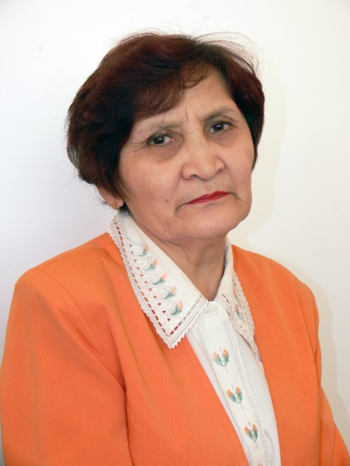

Gulfarida Shamsulovna Orazgalieva

Candidate of Philology, Associate Professor of Linguistics KNASON MES RK
Professor of the Department of Foreign Languages and Intercultural Communication
Contact information:
Address: office 203, 17 Abaya str., Karaganda, 100012 Kazakhstan
Phone: 42-04-25 (ext.303)
E-mail: orazgaliyeva_gulfarida@mail.ru
Working hours: Mon. 11-12.30; Thu. 11-12.30

Education:
1990 (October 13) - Defense of the dissertation of the Kirov KazGU, Alma-Ata (CD No. 044871) on specialty 10.02.01- Russian language
01.12.1979 – 31.12.1982 – Full-time postgraduate study in the specialty "Russian language" at S.M. Kirov KazGU (Alma-Ata);
1966-1970 – Higher education: Philological Faculty of Karaganda State Pedagogical Institute;

Work experience:
2016 (January) – present - Professor of the Bolashak Academy
2008 (September) – 2016 – Associate Professor of the Department of Foreign Languages and Translation of the KU "Bolashak";
2007 (January) - 2008 (August) - Associate Professor of the Department of Classical and Russian Philology of the E.A. Buketov KarSU;
10.01.1997 -2007 (January) – Associate Professor of the Department of General and Russian Linguistics of the KarSU named after E.A. Buketov KarSU;
06.02.1992 – 01.10.1997 – Associate Professor of the Department of Russian Linguistics of the E.A. Buketov KarSU;
26.02.1987 – 06.02.1992 – St.Rev. Department of Russian Linguistics KarSU named after E.A. Buketov;
13.01.1983 – 06.02.1992 - The Rev. of the Department of Russian Linguistics of the KarSU named after E.A. Buketov;
01.12.1979 – 31.12.1982 – postgraduate study in the specialty "Russian language" at S.M. Kirov KazGU (Alma-Ata);
03.02.1977 – 01.12. 1979 - St.Rev. Department of Russian Linguistics KarSU named after E.A. Buketov;
19.01. 1976 – 03.02.1977 – Teacher of the Department of Russian Linguistics of the E.A. Buketov KarSU;
04.09.1973 - 19.01.1976 – methodologist of the Cabinet of Russian language and Literature of the Karaganda Regional Institute of Teacher Improvement Kirov (Alma-Ata);
25.08.1970 - 30.08.1973 – Rev. Departments of Russian Linguistics KarSU

Teaching experience: 52 years

Research interests: cognitive linguistics, linguistic space, linguistic worldview and worldview, anthropocentric paradigm, concepts, linguistic consciousness, cultural connotation, cultural background, semantics, lexeme, word, lexical background, phraseology, paremia, national-cultural semantics, phraseological background, aphoristic background

Scientific and educational-methodical works
More than 110 scientific articles have been published; 3 textbooks "Vocabulary and phraseology as a source of ethnocultural information" (2001), "Workshop on modern Russian: for non-philological specialties" (2009) and "Lexico-phraseological units of language in linguoculturological aspect" (2013); educational and methodological manual "Speech etiquette in ethnolinguistic aspect (2005); 2 collective monographs "Dialogue of Cultures in the Modern World" (2016); "Creating Backward – Looking Forward: a Collective Monograph (2018); Dictionary of Botany (for general education schools) 2018, English-Russian-Kazakh, Russian-English-Kazakh, Kazakh-English-Russian Dictionary of Zoology (for general education schools) 2018, Russian Russian-Kazakh, Kazakh-English-Kazakh, Kazakh-English-Russian dictionary of biology (for secondary schools) 2019

Awards:
Medal "The best candidate of sciences-2019", diploma, certificate, letter of thanks for participation in the contest "The Best candidate of Sciences-2019" within the framework of the republican project "The Best teacher" initiated by the National Innovative Research Center "Bilim-orkeniety" - Nur-Sultan (June 26, 2019).
The Association of Higher Educational Institutions of the Republic of Kazakhstan awarded the medal "Uzdik gylym kyzmetkeri" for contribution to the development of higher education and scientific achievements (August 23, 2019).

Information about inventions (copyright certificate, patent):
Electronic textbook "Vocabulary and phraseology as a source of ethnocultural information": Certificate of State registration of intellectual property Objects No. 292 dated October 26, 2004 of the Ministry of Justice of the Republic of Kazakhstan (2004);

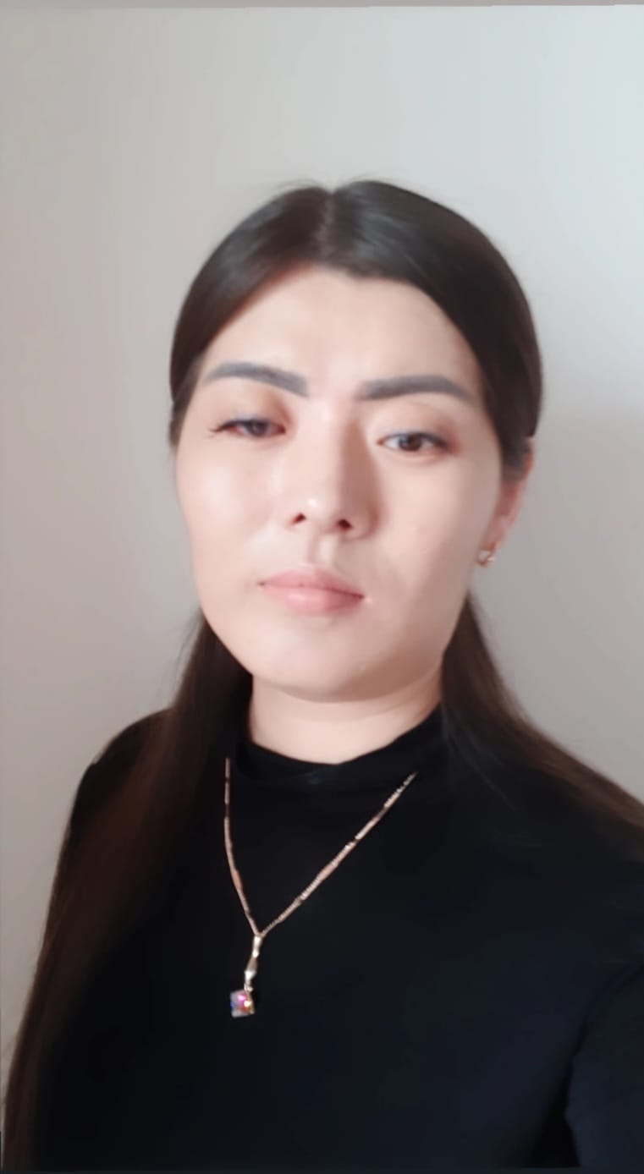

Abdresheva Madina Kabbasovna

Master of Pedagogical Sciences
Senior Teacher of the Department of Foreign Languages and Intercultural Communication

Contact information:
Address: office 203, 17 Abaya str., Karaganda, 100012 Kazakhstan
Phone: 42-04-25 (ext.303)
E-mail: mada_15@mail.ru
Working hours: Mon.-Fri. 09:00-15:00

Education:
2016-2018 – Karaganda State University named after Academician E.A. Buketov, Faculty of Foreign Languages, specialty - foreign language "two foreign languages", qualification – Master of Pedagogical Sciences.
2013-2016 – Karaganda State University named after Academician E.A. Buketov, Faculty of Foreign Languages, specialty – foreign language: "two foreign languages (English)", qualification – Bachelor of Education
2010-2013 – Karaganda College of Current Education, "Translation Business" (with honors)

Work experience:
2021 - present – Senior Teacher of the Department of Foreign Languages and Intercultural Communication at the Bolashak Academy.
2019 (February) - 2022 (June) - English teacher, British Council Astana
2018 (September) - 2021 (August) - Teacher of the Department of Foreign Languages, E.A. Buketov KarSU

Teaching experience: 5 years

Scientific interests: inclusive education, multilingual education, online platforms

Scientific and educational-methodical works
The number of published scientific and educational works is more than 10.
Of these:
- in publications recommended by COXON MES RK, – 2
- in publications published in the RSCI database – 3.

Scientific internships:
2017 (June) Internship on the course "Intensive language course" at the Language school Jipka (Prague, Czech Republic);
2019 (July) Internship in the course "Teaching English to students with different levels and backgrounds" at Cyprus International University

Information about advanced training:
2018 (April 16) Certificate confirming participation in the distance learning course "Methodological support of the inclusive education process" at the E. A. Buketov KarSU
2019 (June 23) Certificate Teaching English as foreign language – TEFL, grade A
2019 (December 9-13) Certificate of "Kazakhstan Education Research Association" at Nazarbayev University
2020 (March 2-5) Certificate "Massive Oriented Online Courses" in the British Council
2020 (April 23) Certificate "Teaching English in higher education" at Macmillan Education in Kazakhstan. Online webinar. Preparation of the team "Kyran", out of 5 students who took 1st place in the I Republican Pedagogical Olympiad "Creative teacher of the XXI century", Taraz, April 25-26, 2017.

Kurman Nurshat Kokkozkyzy

Master of Pedagogical Sciences, Senior Teacher of the Department of Foreign Languages and Intercultural Communication

Contact information:
Address: office 203, 17 Abaya str., Karaganda, 100012 Kazakhstan
Phone: 42-04-25 (ext.303)
E-mail: nurshatkokkozovna@mail.ru
Working hours: Mon.-Fri. 09:00-17:00, lunch 13.00-14:00.

Education:
2020-2022 - Master's degree in Karaganda State University named after E.A. Buketov (Karaganda), Faculty of Foreign Languages, 5B011900 Foreign language: two foreign languages (English). Specialty "Foreign language: two foreign languages (English)".
2013-2017 - Full-time higher education “Bolashaq" Academy (Karaganda), Faculty of Foreign Languages, 5B011900 Foreign language: two foreign languages (English). Specialty "Foreign language: two foreign languages (English)".

Work experience:
2022 - present - Teacher of the Department of "Foreign Languages and Intercultural Communication" CHU Academy "Bolashaq"
2017 (September) - 2021 - English teacher at KSU SHL No. 66, Karaganda.

Teaching experience: 4 years

Research interests: Methodological problems of pedagogy, the nature of pedagogical knowledge, pedagogical education, the nature of pedagogical activity; competence approach in education.

Scientific and educational-methodical works
Published more than 10 scientific articles, 2 projects

Advanced training:
- "Methods of Foreign Language Teaching" based on Seatle University 72 hours Karaganda
- "Teach English Now" based on Coursera, Arizona State University 72 hours Karaganda
- "Management and Quality of Education" based on American University of Malta 30 hours Karaganda
- "Development of digital competence of teachers" based on "NCPC Orleu" 6 o'clock Karaganda
- «Zhanartylgan bilim ayasyndagi "Zhanashyl ustaz" obrazy” on the basis of the Scientific and methodological organization "Ustaz tilegi" 36 hours Astana

Abilzhan Altynai Bolatkyzy

Master of Pedagogical Sciences, Senior Teacher of the Department of Foreign Languages and Intercultural Communication

Contact information:
Address: office 203, 17 Abaya str., Karaganda, 100012 Kazakhstan
Phone: 42-04-25 (ext.303)
E-mail: Altinay_96_96@inbox.ru
Working hours: Mon.-Fri. 09:00-17:00, lunch 13.00-14:00.

Education:
2019-2021 - Master's degree – E.A. Buketov Karaganda State University (now E.A. Buketov Karaganda University) Faculty of foreign languages, Specialty 5B011900 Foreign language: two foreign languages (English).
2014-2018 - Full-time higher education – Bolashaq Academy, Faculty of foreign languages, Specialty 5B011900 Foreign language: two foreign languages (English).

Work experience:
2021 - present - Senior Teacher of the Department of "Foreign Languages and Intercultural Communication" CHU Academy "Bolashaq"
2018 – 2021 - Multidisciplinary Humanitarian and Technical College

Teaching experience: 5 years

Scientific interests: They are connected with the spheres of teaching foreign languages and intercultural communication of teaching foreign languages, as well as with the sphere of the organization of the educational process.

Scientific and educational-methodical works
Published more than 15 scientific articles, 3 projects

Professional development:
- “Professional competence of a teacher of general education disciplines in the conditions of modernization of the system of technical and vocational education” - National Center for Advanced Training “Orleu” 40 hours, 21.01-25.01.2019, Karaganda
- “Modern approaches in technical and vocational education" - Educational and Methodological Center for the Development of Education of the Karaganda region 18 hours, 06/19/2019 Karaganda
- “Linguistics and intercultural communication (French)”- Institute of Retraining and advanced Training “Bilim" 72 hours, 02.09-20.09.2022 Karaganda
- “Modern approaches in teaching English and intercultural communication" - Bilim Institute of Retraining and Advanced Training 72 hours, 28.09-12.10.2022, Karaganda

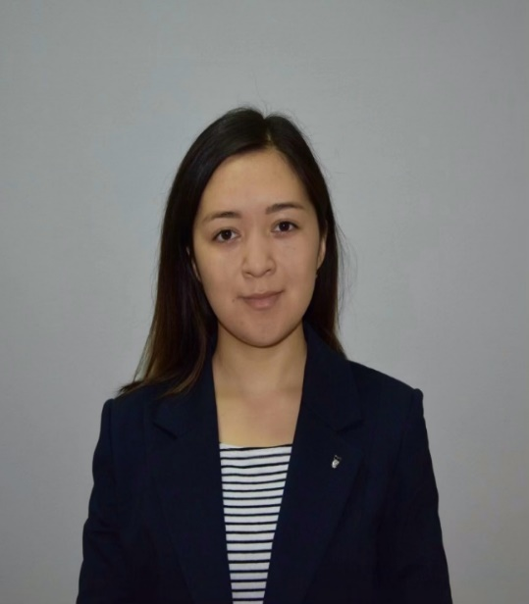

Dauletbaeva Aida Erlanovna

Master of Pedagogical Sciences,
Teacher of the Department of "Foreign Languages and Intercultural Communication"

Contact information:
Address: office 203, 17 Abaya str., Karaganda, 100012 Kazakhstan
Phone: 42-04-25 (ext.303)
E-mail: aida-maerbekova@inbox.ru
Working hours: Mon.-Fri. 09:00-17:00, lunch 13.00-14:00.

Education:
2019-2021 - Master's degree in Karaganda State University named after E.A. Buketov (Karaganda), Faculty of Foreign Languages, 5B011900 Foreign language: two foreign languages (English). Specialty "Foreign language: two foreign languages (English)".
2015-2019 - Full-time higher education Karaganda State University named after E.A. Buketov (Karaganda), Faculty of Foreign Languages, 5B011900 Foreign language: two foreign languages (English). Specialty "Foreign language: two foreign languages (English)".

Work experience:
2021 – present - Teacher of the Department of "Foreign Languages and Intercultural Communication" CHU Academy "Bolashaq"

Teaching experience: 2 years

Scientific interests: They are connected with the study of the pedagogical aspect in the system of foreign language education, with the development of scientific potential provided that an individual trajectory of professional development is built, technological innovations and innovations in linguodidactics, pedagogical management.

Scientific and educational-methodical works
Published more than 20 scientific articles, 2 projects

Awards:
2022 - Honorary diploma of the Rector of the CHU Academy "Bolashaq" for his contribution to the training of future specialists and active participation in the public life of the Academy

Professional development:
- "Modern approaches in teaching English and intercultural communication" in the amount of 72 hours, 10-28.08.22 (Karaganda),
- "Deep Reading" in the amount of 36 hours, 21.07-5.08.22 (Galway, Ireland),
- "Principles of Academic Writing" in the amount of 36 hours, 21.07-5.08.22 (Galway, Ireland),
- "English for IELTS" in the amount of 72 hours, 5-24.09.22 (Karaganda).

